Hoot Owl Days
Food Vendor
Sat., Aug. 24, 2019
Fun in the Park!
9:00 AM – 4:00 PM
Hubbard Hoot Owl Days
Heffernan Park
Hubbard, NE

Contact person: Jessica Rohde 402-404-1816 (text or call)

Name______________________________________________________________

Address____________________________________________________________

Phone #____________________________________________________________

Email______________________________________________________________

Product Description__________________________________________________

All spots outside – Bring your own trailer, table, tent, chair, etc.
Sat. Aug 24, 2019 9:00 AM – 4:00 PM

Send form and $50 by Aug. 1, 2019 to:
Hubbard Betterment
PO Box 160
Hubbard, NE 68741
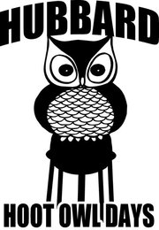
Fun in the Park!

Come to Hubbard – We’ll have a “HOOT”!

