Hoot Owl Days
Non-Food Vendor
Sat., Aug. 25, 2018
NEW! Lower price
Fun in the Park!
11:30 AM – 4:00 PM
Hubbard Hoot Owl Days
Heffernan Park
Hubbard, NE

Contact person – Jessica at (402) 404-1816 or Pat (712) 212-0338

Name______________________________________________________________

Address____________________________________________________________

Phone #____________________________________________________________

Email______________________________________________________________

Product Description__________________________________________________

Electricity needed? ______No ______Yes

All spots outside – Bring your own trailer, table, tent, chair, etc.
Sat. Aug 25, 2018 11:30 AM – 4:00 PM

Send form and $10 by Aug. 1, 2018 ($15 after Aug. 1) to:
Hubbard Betterment
PO Box 160
Hubbard, NE 68741
NEW! Lower price
*The $10 fee is non-refundable
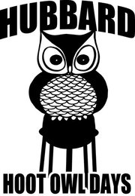
Fun in the Park!

Come to Hubbard – We’ll have a “HOOT”!

